Difference between JDK, JRE and JVM
Understanding the difference between JDK, JRE and JVM is important in Java. We are having brief overview of JVM here.
If you want to get the detailed knowledge of Java Virtual Machine, move to the next page. Firstly, let's see the basic differences between the JDK, JRE and JVM.

JVM
JVM (Java Virtual Machine) is an abstract machine. It is a specification that provides runtime environment in which java bytecode can be executed.
JVMs are available for many hardware and software platforms. JVM, JRE and JDK are platform dependent because configuration of each OS differs. But, Java is platform independent.
The JVM performs following main tasks:
- Loads code
- Verifies code
- Executes code
- Provides runtime environment

JRE
JRE is an acronym for Java Runtime Environment.It is used to provide runtime environment.It is the implementation of JVM.It physically exists.It contains set of libraries + other files that JVM uses at runtime.
Implementation of JVMs are also actively released by other companies besides Sun Micro Systems.
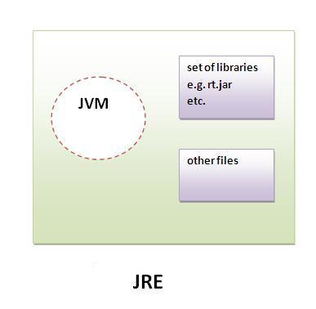

JDK
JDK is an acronym for Java Development Kit.It physically exists.It contains JRE + development tools.
